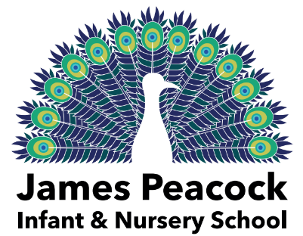
26th May 2023
Nursery Trip to Manor Farm Park
Thursday 15th June 2023

Dear Parents and Carers,

We are delighted to confirm that we have been able to book the farm and transport for the 49 children who opted to attend.
Due to numbers and some negotiation, we are now able to take all 49 children to the farm on one day Thursday 15th June and as a result we have been able to secure the price at £19.50 per child.
This charge is also applicable for children who have an annual pass, as the pass does not cover the transport or the adult-led school package that we are accessing.
The trip can now be paid for by those who have expressed that they wish to come via ParentPay.
As with all trips, this is a voluntary contribution and without securing the funds we may not be able to proceed.
Thank you to all parents/carers who have offered to come on the trip. We were grateful to have had more volunteers than were required, so have therefore contacted the parents who were first to respond to confirm their availability. Class teachers will provide details of timings and share risk assessments and roles with those adults.
Children attending the trip should come to nursery at the normal time (8.30am) on this day please, with a packed lunch and named water bottle in a small rucksack/bag. Please also ensure children have all-day suncream applied if applicable and a named sun-hat, as well as a waterproof in case of variable weather. You’re welcome to collect your children at the normal time.
Have a lovely half term and we look forward to seeing you all soon.

Best wishes,
Miss Hawthorne & the Nursery Team

